

Supermarket Customer Queue

  - By: Tanya Dominique
  - ID# 2504_29135
  - Module: Data Structures and Algorithms

TABLE OF CONTENTS

INTRODUCTION…………………………………….………..3

SOFTWARE SPECIFICATIONS………………………………3

Variables Used…………………………………………....3

Functional Requirements Implemented……………….….5

Menu Layout……………………………..……………….7

Customer Class…………………………………………...8

2.5 CustomerQueue Class………………………………….....9

TESTING PHASE………………………………………….....10

Sample Data and Execution……………………………..10

Confirmation Dialogs and Backend Behaviour……........12

Error Handling ………………………………………...12

CONCLUSIONS DRAWN……………………………………14

Strengths………………………………………………...14

Limitations……………………………………………...14

INTRODUCTION
This program was created to see how a LinkedList class could make use of various queue functionalities. A Customer class was created to store the objects ‘customer’, ‘served’ and ‘next’, each with their own functions and use cases.
A Queue in Java is a data structure defined as an interface, hence it must be declared using a data structure class such as a LinkedList. A queue then orders a data structure in a FIFO (first-in, first-out) manner, where the first element added in the queue is the first element out of the queue.

2.0 SOFTWARE SPECIFICATIONS

2.1 Variables Used
TYPE | NAME | PURPOSE | USED IN (GUI NAME FOR BUTTONS)
STRING | customerId | To store and format customer Id | Used indirectly through methods
STRING | customerName | To store customer name | addBtn; indirectly through methods
STRING | itemsStr | Stores itemsCount input as String | addBtn
STRING | totalStr | stores totalAmount input as String | addBtn
INTEGER | itemsCount | Stores number of items | addBtn
INTEGER | customerIdCounter | Keeps track of ID number and auto-increments | Used indirectly through methods
INTEGER | totalServed | Keeps track of number of customers served | Used indirectly through methods
INTEGER | i | Used in if loop | Used indirectly through methods
DOUBLE | totalAmt | Returns total cost of items | addBtn
BOOLEAN | success | To verify if customer was successfully added | addBtn
STRINGBUILDER | sb | Stores the formatted Customer values together | Used indirectly through methods
GET METHODS | getCustomerId() | Returns customerId | Used indirectly
GET METHODS | getCustomerName() | Returns customerName | Used indirectly
GET METHODS | getItemsCount() | Returns itemsCount | Used indirectly
GET METHODS | getTotalAmt() | Returns totalAmt | Used indirectly
GET METHODS | getTotalServed() | Returns totalServed | Used indirectly
SET METHODS | setCustomerId() | Updates customerId | Used indirectly
SET METHODS | setCustomerName() | Updates customerName | Used indirectly
SET METHODS | setItemsCount() | Updates itemsCount | Used indirectly
SET METHODS | setTotalAmt() | Updates totalAmt | Used indirectly
CUSTOMER CLASS METHODS | toDetailedString() | Formats customer input | serveBtn, peekBtn, addBtn
CUSTOMERQUEUE (AND CQUEUE)  METHODS | CustomerQueue() | Initialises cQueue and totalServed values | Used indirectly
CUSTOMERQUEUE (AND CQUEUE)  METHODS | enqueueCustomer() | Method to add customers | addBtn
CUSTOMERQUEUE (AND CQUEUE)  METHODS | serveCustomer() | To serve the current customer | serveBtn
CUSTOMERQUEUE (AND CQUEUE)  METHODS | peekNext() | To peek next customer | peekBtn
CUSTOMERQUEUE (AND CQUEUE)  METHODS | displayQueue() | Displays customer queue | seeAllBtn
CUSTOMERQUEUE (AND CQUEUE)  METHODS | size() | Returns cQueue size | Used indirectly through methods
CUSTOMERQUEUE (AND CQUEUE)  METHODS | isEmpty() | Method to check if field is empty | peekBtn, serveBtn, seeAllBtn, addBtn
QUEUE | Queue<Customer> | Creates a new queue using object Customer | Used indirectly
BUTTONS | peekBtn | To peek next customer | Serve
BUTTONS | serveBtn | To serve current customer | Peek Next
BUTTONS | seeAllBtn | To see all customers in queue | See All
BUTTONS | addBtn | To add new customer to back of the queue | Add New
BUTTONS | clrAllBtn | To clear all data | Clear All

2.2 Functional Requirements Implemented
F1. Enqueue Customer
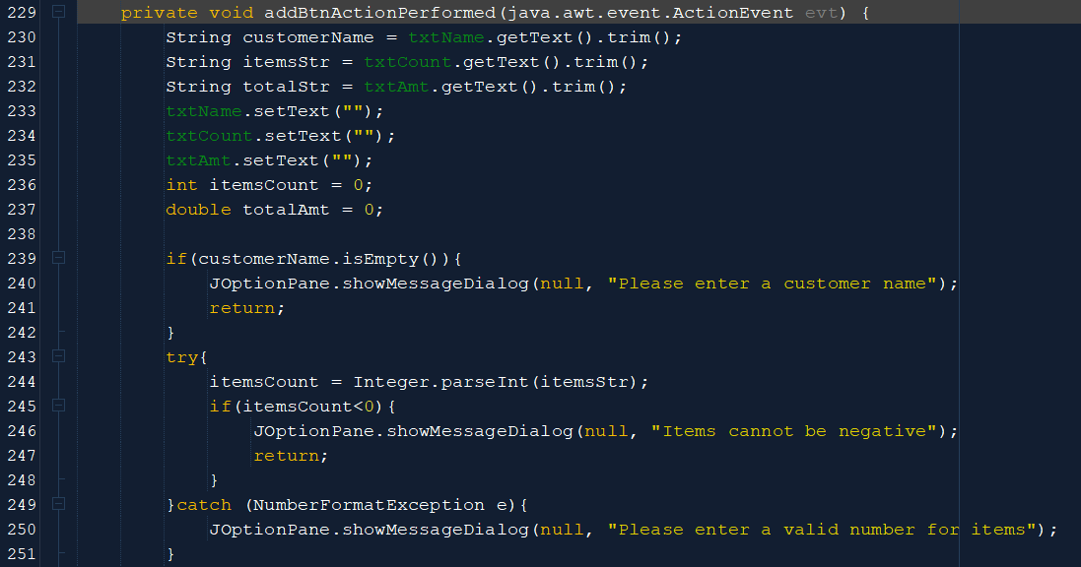
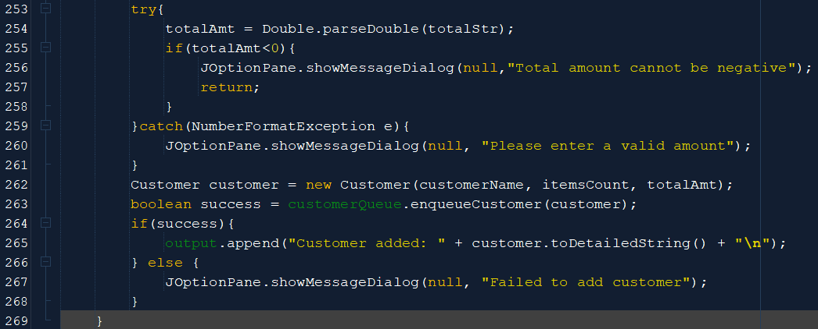
Images 1&2: How ‘Enqueue Customer’ was implemented
F2. Serve Customer
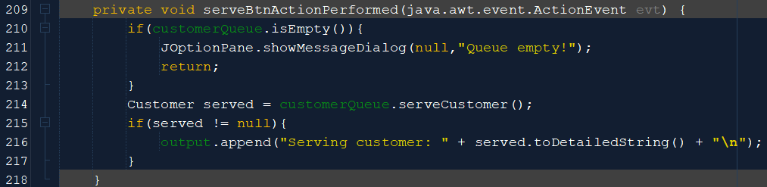
Image 3: How ‘Serve Customer’ was implemented

F3. Peek Next Customer
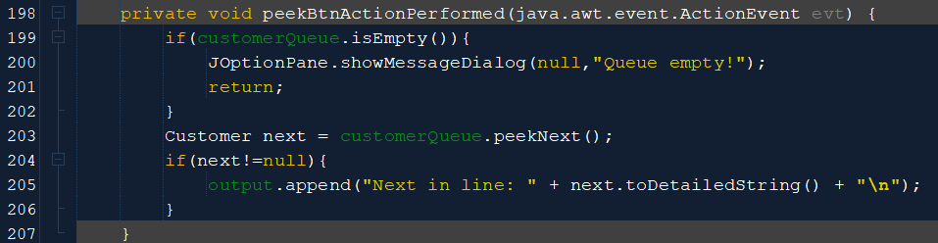
Image 4: How ‘Peek Next Customer’ was implemented
F4. Display Queue
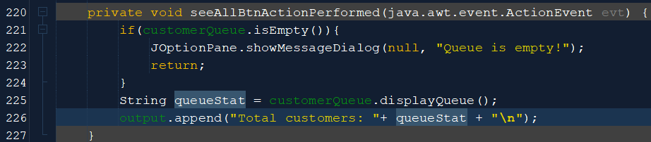
Image 5: How ‘Display Queue’ was implemented
F5. Clear All Data
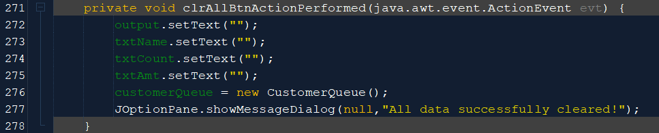
Image 6: How ‘Clear All Data’ was implemented

2.3 Menu Layout
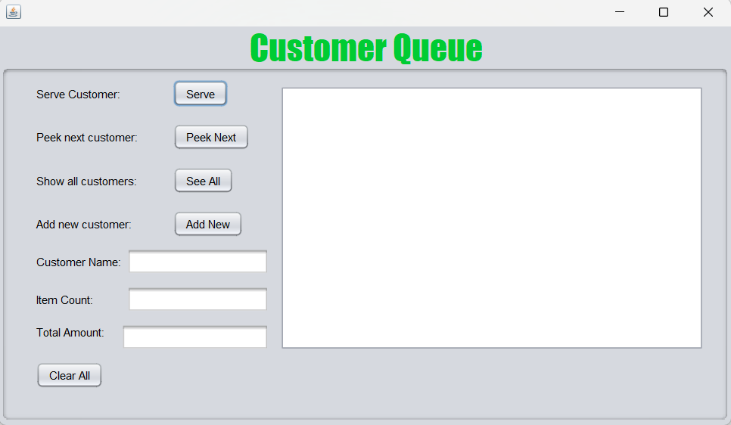
Image 7: Customer Queue GUI
Here we have the GUI for this application with several interactive elements:
Serve button: This button serves the next customer and makes use of the serveCustomer() method defined in the CustomerQueue class. It has the output:
Serving customer: <customerName> (ID: C00<customerId>) – Items: <itemsCount>, Amount: $<totalAmt>
Peek Next button: This button shows the customer next in line and makes use of the peekNext() method defined in the CustomerQueue class. It has the output:
Next in line: <customerName> (ID: C00<customerId>) – Items: <itemsCount>, Amount: $<totalAmt>
See All button: This button shows the customer’s name and ID of all the customers currently in line and makes use of the displayQueue() method in the CustomerQueue class. It has the output:
Total customers: [<customerName1> (ID: C00<customerId1>), <customerName2> (ID: C00<customerId2>)… <customerNameMax> (ID: C00<customerIdMax>)]
Add New button: This button adds a new customer to the back of the queue and makes use of the enqueueCustomer() method in the CustomerQueue class. It has the output:
Customer added: <customerName> (ID: C00<customerId>) – Items: <itemsCount>, Amount: $<totalAmt>

2.4 Customer.java Class
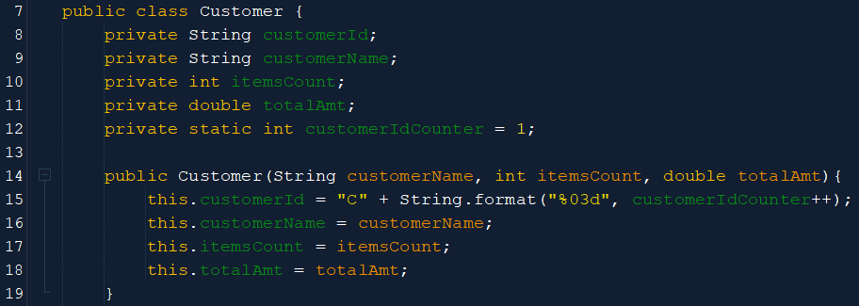
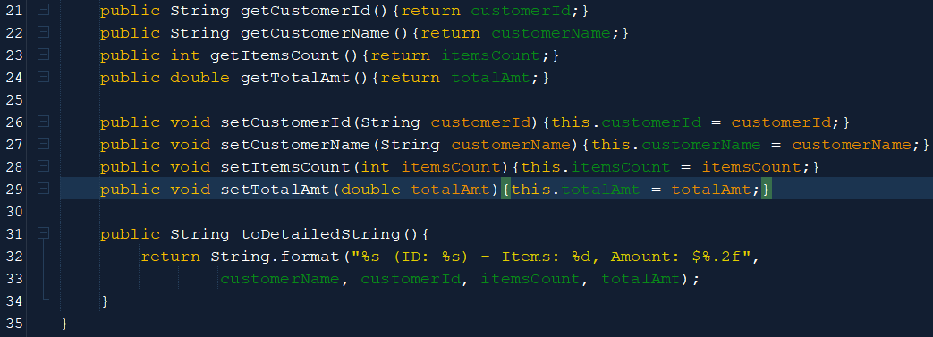
Images 8&9: Customer Class methods
The Customer class defines various attributes associated to the entity ‘Customer’ and, using these attributes, various methods are defined.

Methods Defined:
Getter Methods: these all return the predefined variables when called
- getCustomerId
- getCustomerName
- getItemsCount
- getTotalAmt
Setter Methods: these update the variables to be whatever input is given when called
- setCustomerId
- setCustomerName
- setItemsCount
- setTotalAmt
Other Methods:
- toDetailedString – returns a formatted string of all customer attributes when called

2.5 CustomerQueue.java Class

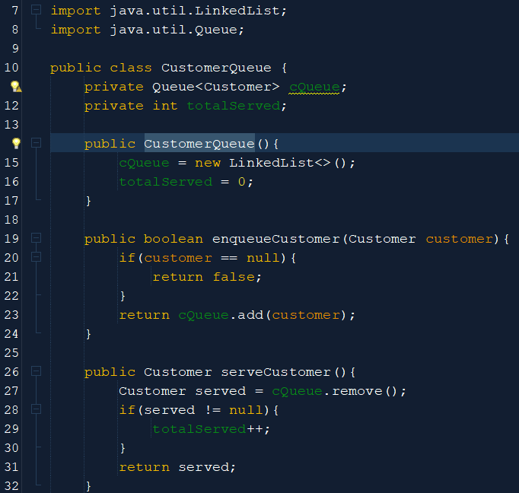
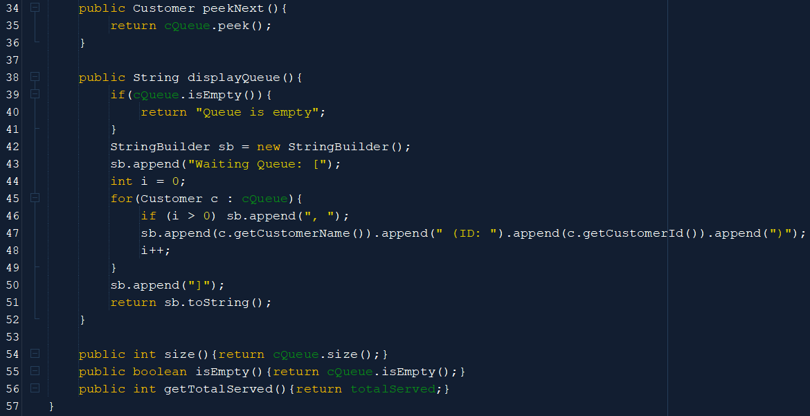
Images 10&11: CustomerQueue Class methods
The CustomerQueue class defines the object ‘Customer’ as being a Queue of type LinkedList. Various methods are defined using the Customer class and the object cQueue of CustomerQueue class. They each alter how various objects of class Customer are displayed, depending on which method is being called.

Methods Defined:
- CustomerQueue – initialises the LinkedList and totalServed counter
- enqueueCustomer – adds a customer to the Queue and increases the totalServed counter by one for each customer added when called
- serveCustomer – serves current customer when called
- peekNext – peeks at next customer in queue when called
- displayQueue – displays all customers currently in queue when called
- size – returns the size of cQueue when called
- isEmpty – returns cQueue as being empty when called
- getTotalServed – returns the total number of customers served when called. This helps in auto-incrementation of ID

3.0 TESTING PHASE

3.1 Sample Data and Execution
Sample Data:
- Kylian Hakimi (ID: C001) – Items: 5, Amount: $45.50
- Luka Neymar (ID: C002) – Items: 3, Amount: $27.80
- Messi Ronaldo (ID: C003) – Items: 8, Amount: $92.30
- Mbappe Vini (ID: C004) – Items: 4, Amount: $58.20
- Ronaldinho Pele (ID: C005) – Items: 6, Amount $72.50
This was the expected outcome:
After first 4 customers added:
Customer added: Kylian Hakimi (ID: C001) – Items: 5, Amount: $45.50
Customer added: Luka Neymar (ID: C002) – Items: 3, Amount: $27.80
Customer added: Messi Ronaldo (ID: C003) – Items: 8, Amount: $92.30
Customer added: Mbappe Vini (ID: C004) – Items: 4, Amount: $58.20
After 2 customers were served:
Serving Customer: Kylian Hakimi (ID: C001) – Items: 5, Amount: $45.50
Serving Customer: Luka Neymar (ID: C002) – Items: 3, Amount: $27.80
After see all was pressed:
Total customers: Waiting Queue: [Messi Ronaldo (ID: C003), Mbappe Vini (ID: C004)]
After new customer was added:
Customer added: Ronaldinho Pele (ID: C005) – Items: 6, Amount $72.50
After see all was pressed:
Total customers: Waiting Queue: [Messi Ronaldo (ID: C003), Mbappe Vini (ID: C004), Ronaldinho Pele (ID: C005)]
After peek next was pressed:
Next in line: Messi Ronaldo (ID: C003) – Items: 8, Amount: $92.30
After customer was served
Serving Customer: Messi Ronaldo (ID: C003) – Items: 8, Amount: $92.30
After peek next was pressed:
Next in line: Mbappe Vini (ID: C004) – Items: 4, Amount: $58.20
After 2 customers were served:
Serving Customer: Mbappe Vini (ID: C004) – Items: 4, Amount: $58.20
Serving Customer: Ronaldinho Pele (ID: C005) – Items: 6, Amount $72.50
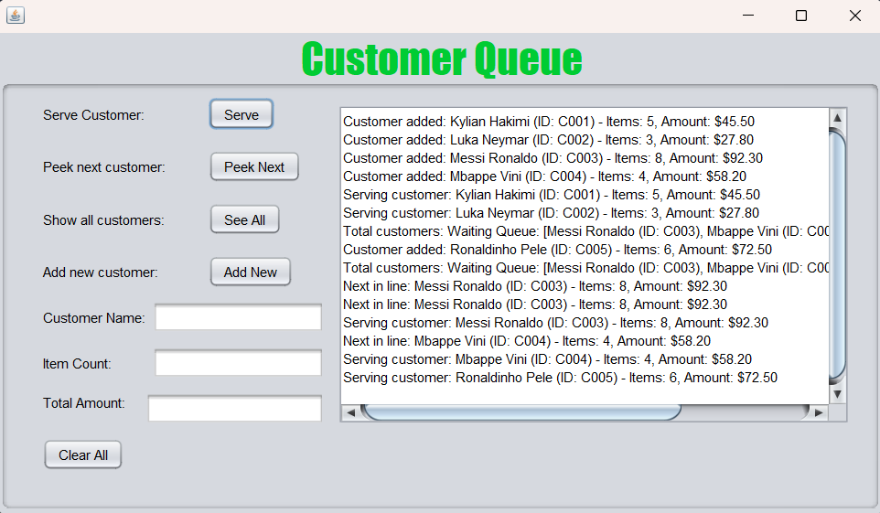
Image 12: Sample Data Execution in output Area

3.2 Confirmation Dialogs and Backend Behaviour
As most of the data entered is displayed directly into the output area, not many confirmation dialogs were necessary, apart from when data was cleared:
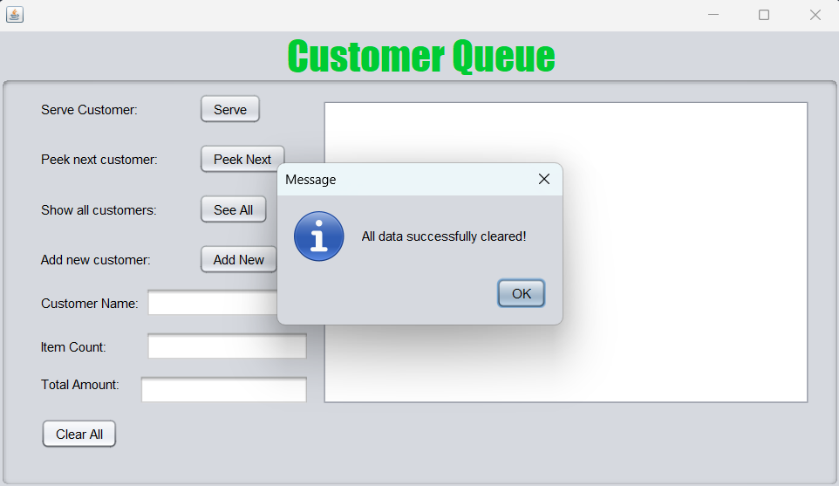
Image 13: Confirmation dialog for data being successfully cleared

3.3 Error Handling (Popups/Messages)
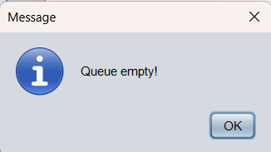
Image 14: Error message for when trying to serve a customer with empty queue

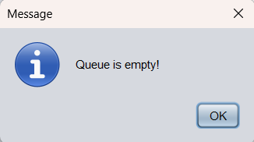
Image 15: Error message for when trying to peek the next customer with empty queue
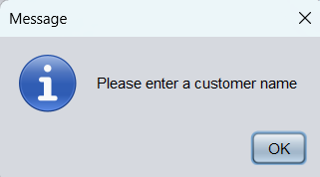
Image 16: Error message for when trying to input a customer without a name
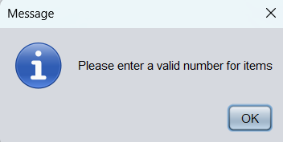
Image 17: Error message for when trying to input a customer with no items
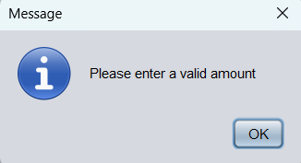
Image 18: Error message for when trying to input a customer where no cost is recorded

4.0 CONCLUSIONS DRAWN

4.1 Strengths
Here are some of the strengths this program holds:
- Appropriate error messages displayed for trying to input customers with insufficient data
- Methods used to perform operation that would otherwise be complex without them

4.2 Limitations
Here are some of the limitations this program holds:
- Customers cannot be removed directly from the queue, hence all customers that have entered must be served
- Customers cannot be updated within this program

